Grade 7 Accelerated · Unit 3 · Lesson 1  Product Laws of Exponents  Independent Set 3.01 ANSWER KEY | Name  Date  Period

Six questions, on your own, in silence. Show the step that does the work.
1. Write as one power. 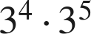


2. Find the value. 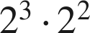


3. Write as one power. 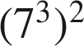

Power of a power: multiply.

4. Find the value. 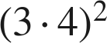
144
3² · 4² = 9 · 16, or 12².

5. Find the value. 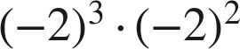

An odd power of a negative base is negative.

6. Find the value of . 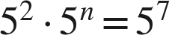
n = 5
2 + n = 7.

